 Physics Activity: The Magnus Effect

**Time:** 15 min

**Overview/Introduction:** The magnus effect is commonly observed in objects spinning in a fluid. A lift force is applied to the object due to the spinning motion and deflects the trajectory away from the one that would be followed if there were no spin. This effect is commonly observed when kicking and shooting soccer balls - think about scoring goals from a corner kick!

**ILOs:**

1. Understand the effect of spin and airflow on the trajectory of objects
2. Observe and demonstrate the deviation from expected trajectory (curving) using the built object from cups.

**Equipment List:**

**2 cups (light) (per student)**

**4 rubber bands (per student)**

**tape**

**Summary:** Let's create a device based on the information described below. You will “throw” the cups, and they will spin as they fly through the air. Rotating the cups will allow for the Magnus Effect, and you will see it in person.

**Worksheet?**

No - answer discussion questions with your groups!

**Procedure:**

1. To start, tape the base of the cups together.

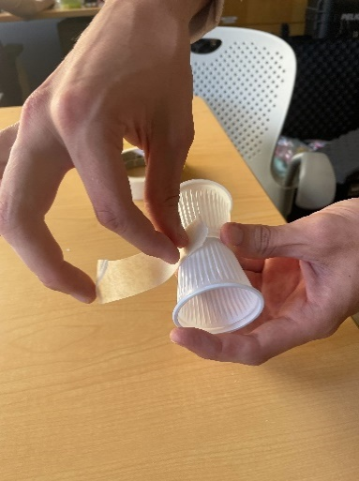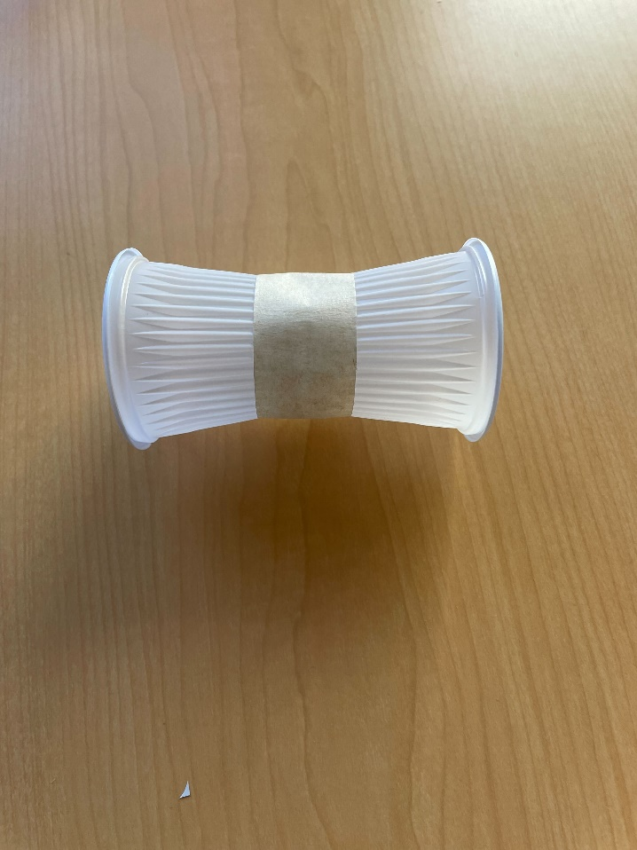

1. Next, loop elastic bands together until you have a string of 4 connected bands.

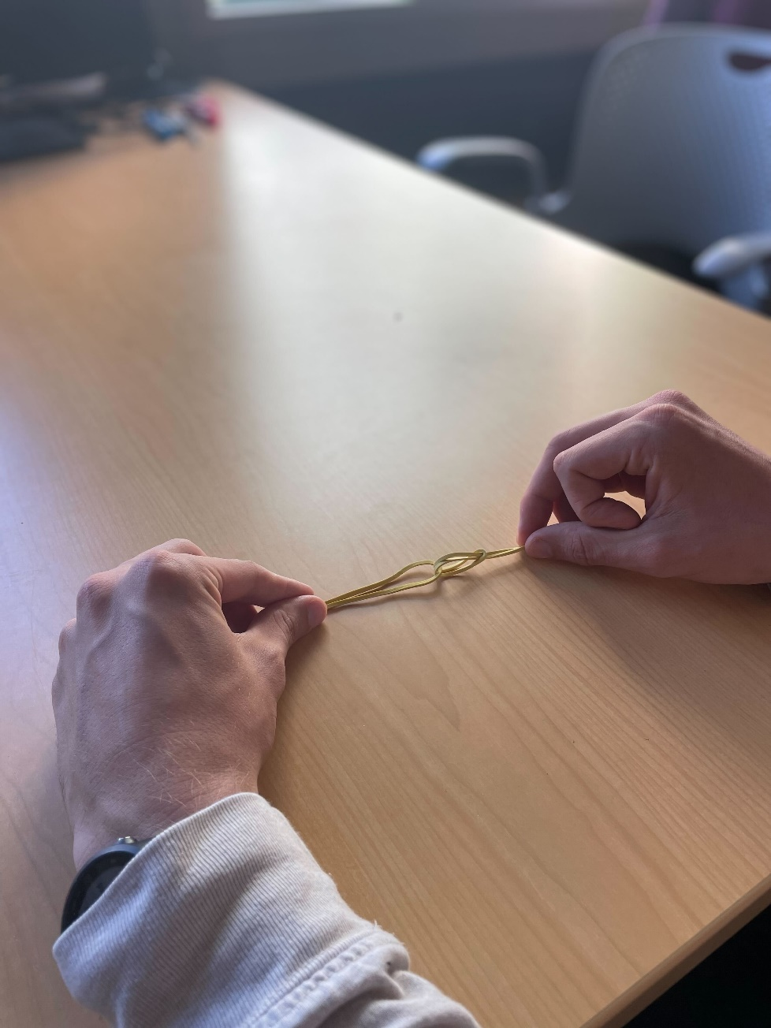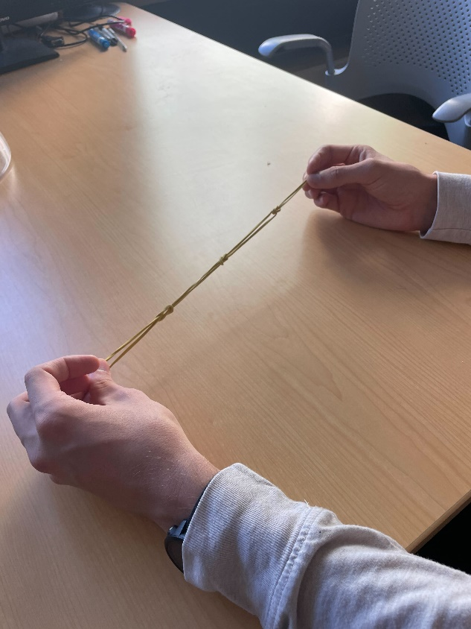

1. Now, wrap the rubber band chain around the center of the taped cups. 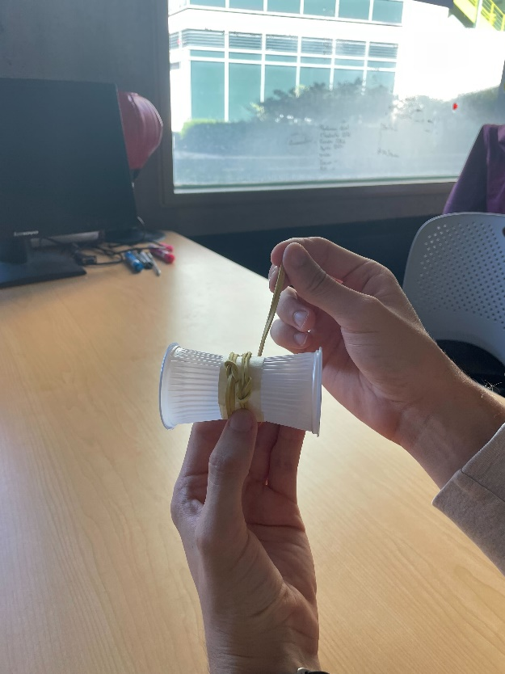
2. You’re ready! Stretch the elastic and release! Note what you observe.



**Discussion Question:**

1. Did the cups move in the way you expected them to? What happened that you did or did not expect? Did you observe lift?

1. Advanced: How does the shape of the object change how the magnus effect is observed? How does the weight of the object change how the magnus effect is observed?